ASSIGNMENT NO.5
Aggregate Functions and Data Analysis

Q1) Create a MySQL database named CollegeDB and a table named StudentResult.
The table should contain the following columns:
Column Name Data Type
Constraint
StudentID
INT
PRIMARY KEY
StudentName
VARCHAR(50)
Course
VARCHAR(30)
City
VARCHAR(30)
Marks
INT
FeesPaid
DECIMAL(10,2)

CREATE DATABASE CollegeDB;

USE CollegeDB;

CREATE TABLE StudentResult (
StudentID INT PRIMARY KEY,
StudentName VARCHAR(50),
Course VARCHAR(30),
City VARCHAR(30),
Marks INT,
FeesPaid DECIMAL(10,2)
);

INSERT INTO StudentResult
(StudentID, StudentName, Course, City, Marks, FeesPaid)
VALUES
(1, 'Amit Sharma', 'BCA', 'Pune', 85, 45000.00),
(2, 'Priya Patel', 'BCA', 'Mumbai', 92, 48000.00),
(3, 'Rahul Verma', 'BSc IT', 'Pune', 76, 42000.00),
(4, 'Neha Singh', 'BCA', 'Nashik', 88, 45000.00),
(5, 'Rohan Mehta', 'BSc IT', 'Mumbai', 69, 40000.00),
(6, 'Sneha Joshi', 'BCA', 'Nagpur', 95, 50000.00),
(7, 'Karan Shah', 'BSc CS', 'Pune', 81, 43000.00),
(8, 'Pooja Desai', 'BSc CS', 'Surat', 73, 41000.00),
(9, 'Vikas Kumar', 'BCA', 'Delhi', 64, 39000.00),
(10, 'Anjali Rao', 'BSc IT', 'Bangalore', 90, 47000.00);





Q2) Write MySQL queries to find the following from the StudentResult table:
Requirement
Total number of students
Total fees paid
Average marks
Lowest marks
Highest mark

SELECT COUNT(*) AS TotalStudents
FROM StudentResult;

SELECT SUM(FeesPaid) AS TotalFeesPaid
FROM StudentResult;

SELECT AVG(Marks) AS AverageMarks
FROM StudentResult;

SELECT MIN(Marks) AS LowestMarks
FROM StudentResult;

SELECT MAX(Marks) AS HighestMarks
FROM StudentResult;







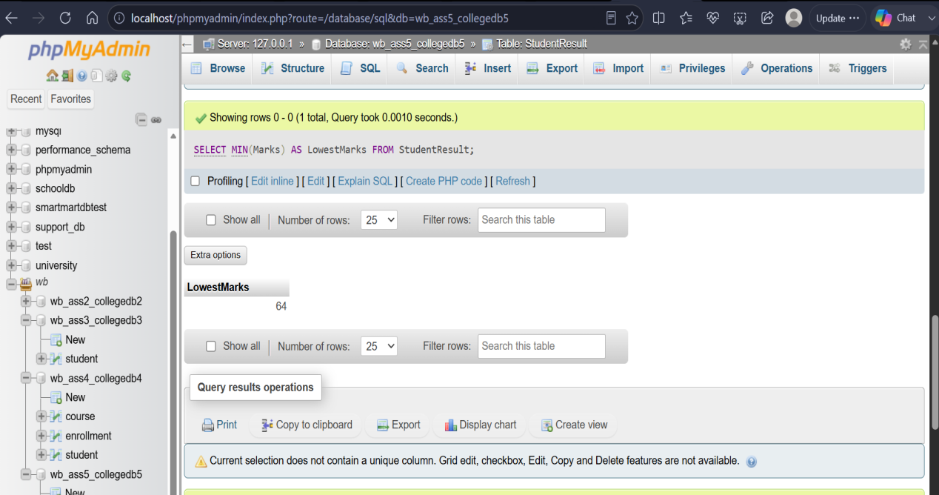



Q3) Write a MySQL query to count the number of students in each course.
The output should contain:
Column
Course
TotalStudents

SELECT Course, COUNT(*) AS TotalStudents
FROM StudentResult
GROUP BY Course;



Q4) Write a MySQL query to find the average marks of students course-wise.
The output should contain:
Column
Course
AverageMarks

SELECT Course, AVG(Marks) AS AverageMarks
FROM StudentResult
GROUP BY Course;

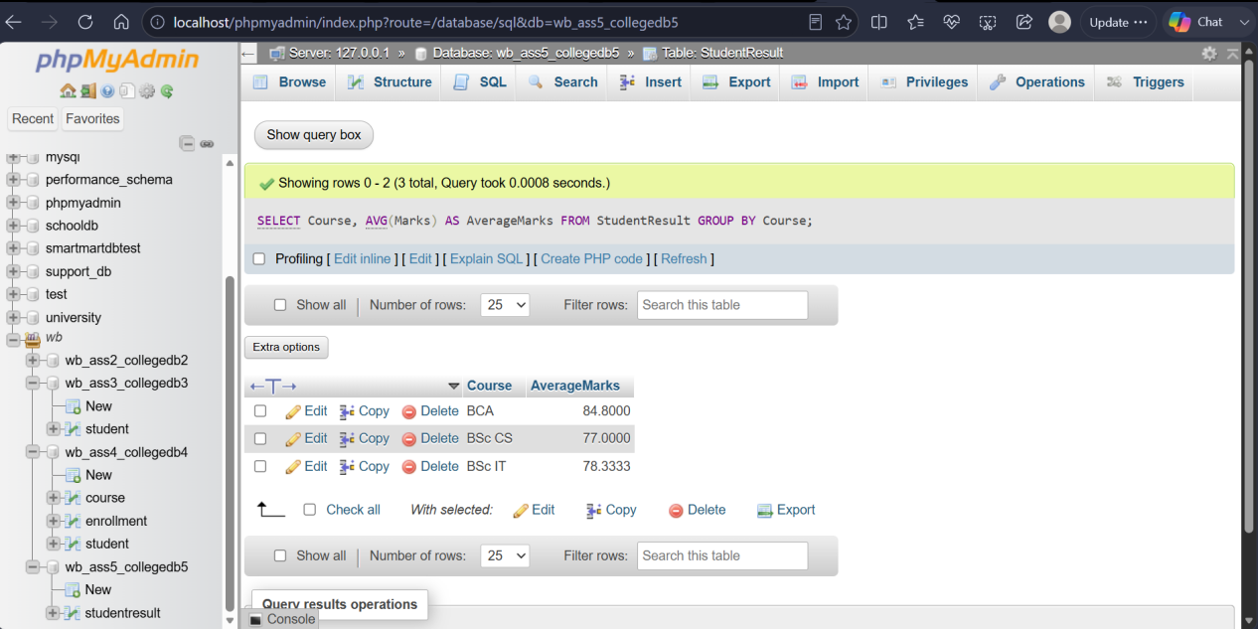

Q5) Write a MySQL query to display only those courses where the number of students is
greater than 2.
Use:
Clause
GROUP BY
HAVING

SELECT Course, COUNT(*) AS TotalStudents
FROM StudentResult
GROUP BY Course
HAVING COUNT(*) > 2;



Q6) Write a MySQL query to analyze course performance.
The output should display:
Requirement
Total number of students
Total fees paid
Average marks
Lowest marks
Highest marks
Column
Course46
B.SC. DATA SCIENCE
Sort the result by AverageMarks in descending order.

SELECT
Course,
COUNT(*) AS TotalStudents,
AVG(Marks) AS AverageMarks,
MIN(Marks) AS LowestMarks,
MAX(Marks) AS HighestMarks
FROM StudentResult
GROUP BY Course
ORDER BY AverageMarks DESC;

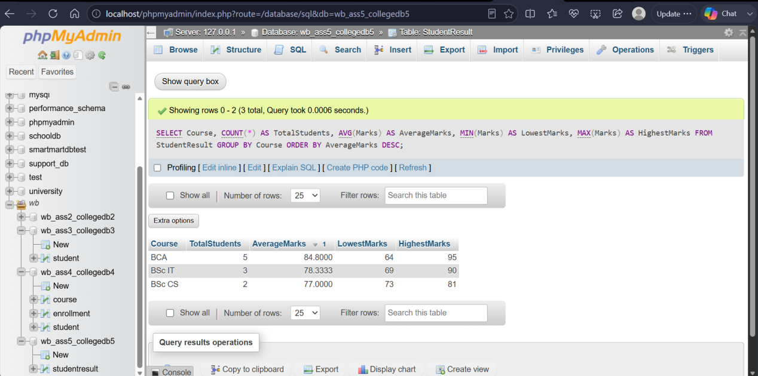

THANK YOU

